Solar Together scheme
Introduction
After a successful two years with iChoosr, Wiltshire Council has partnered up with them once more to do the Solar Together scheme. Solar Together is a project that has been created to give households and businesses an affordable installation on solar panels and battery storage system instalments through a group-buying deal. The scheme offers reassurance to residents by appointing a pre-vetted installer and providing a fully supported customer journey.
Since the Solar Together scheme started, over 1,100 installations and 10,000 solar panels have been installed in Wiltshire, leading to a CO₂ reduction of over 22,000 tonnes in Wiltshire.
The scheme allows participants to have the following systems installed:
- Solar PV
- Battery Storage
- EV Charge Points
If a resident has already had solar PV installed, they can retrofit their systems with battery storage instead.

How you can register
To be a part of the scheme, residents can register online before 9th August at https://solartogether.co.uk/Wiltshire/landing or https://solartogether.co.uk/swindon/landing. They will be asked to fill out a quick questionnaire with personal details to determine whether they are eligible for rooftop solar panels, battery installation, or both.
The questionnaire will ask for information such as address, roof type, and energy usage. The solar installer can then use this information to assess whether the resident's rooftop is appropriate for solar panels and batteries and whether they are a suitable candidate for solar energy.
What happens after signing up?
An auction will be held for pre-vetted installers submit bids for the work. Once the winner is selected, individuals who have registered will receive a personalised recommendation based on the information provided during registration. They can then accept the offer online and pay a deposit.
The chosen installer will contact the individual to survey their roof and schedule the installation.
How is a personal recommendation created?
The recommendation considers the residents estimated yearly electricity consumption, roof size, and battery capacity preference. The comprehensive recommendation includes:
- Recommended number of panels or battery capacity
- Benefits of the panels or battery
- Total package price
- Documents: installer info, product specs, terms and conditions, and next steps explained
If the registrant is interested in getting an electric vehicle charging point, it won't be included in your initial Solar Together personal recommendation.

What you can do to help
We are seeking ways to spread the word about this project, and we’d be grateful to use your local expertise, contacts and networks to help with this. Enclosed you will find some example communications materials that we’d be grateful if you could share on social media, newsletters that you contribute to or any other channels you use such as websites, notice boards etc. The below has been written in a way which means you can simply copy and paste the information into whatever format you have available.

Communication materials:
X (AKA Twitter)
- Did you know? In the first two years of #SolarTogether over 10,000 solar panels were installed, helping residents lower their energy bills and CO2 emissions! Join the scheme before 9th August and let the sun power your home! More info https://solartogether.co.uk/blog/save-money-on-energy-bills-with-solar-pv-system/


- Calling all business owners! Did you know you are able to participate in the #SolarTogether scheme? Businesses can register and own a standard package of 4-25 solar panels! More info https://solartogether.co.uk/blog/what-is-a-group-buying-for-solar-scheme/
Register before 9th August at https://solartogether.co.uk/wiltshire/home


Facebook
- 🏠 Homeowners! Do you know how much you could save on your bills by installing solar panels? Find out by registering for the Solar Together Scheme. You will receive a free personal estimate based on your energy needs and roof type. Register before 9th August at https://solartogether.co.uk/wiltshire/home

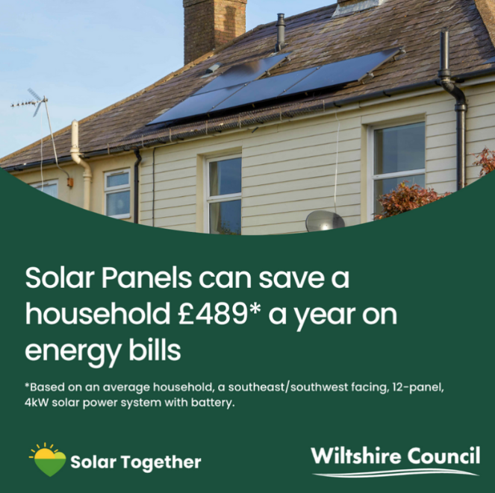

- Through our #SolarTogether scheme over 10,500 solar panels were installed, helping residents lower their energy bills and CO2 emissions! More info How to save money on your energy bills with a solar PV system (solartogether.co.uk) Register before 9th August at https://solartogether.co.uk/wiltshire/home


- “Easy and reassuring!” says Ruth, benefiting from Solar Together with their 14 solar panels and battery storage. Register your interest before 9th August for the #SolarTogether scheme at https://solartogether.co.uk/wiltshire/home
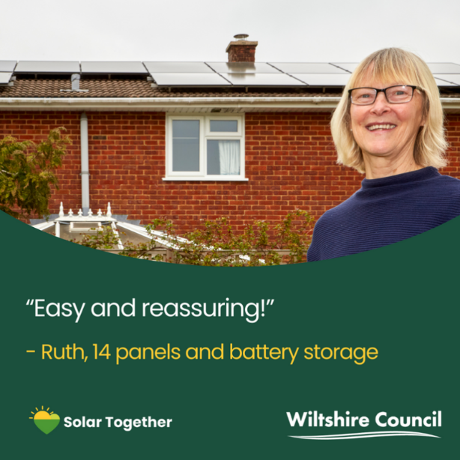

Newsletter Article


Following the success of the previous schemes in 2022 and 2023, we’ve launched a third solar together scheme with Swindon Borough Council and independent group-buying experts, iChoosr.
Solar Together is a group buying initiative where residents can club together to get the best prices for solar panels and installation as well as battery storage and EV chargers from trusted providers.
The process is straightforward with dedicated support throughout, and residents can expect to make a 10-25% saving against the market average.
The previous schemes have delivered 1,110 installations, totalling more than 10,660 solar panels and resulting in over £11 million invested by residents into the green economy. All of the schemes combined are also estimated to lead to a reduction of 22,000 tonnes of CO2 over the 25-year guaranteed lifetime of the solar panels installed.
The scheme is a great opportunity to reach the climate targets for the county and for residents to save money on their energy bills, and even sell excess energy back to the national grid.
You can register your interest with no obligation to accept the deal that if offered to you. Find out more and register your interest before 9th August at https://solartogether.co.uk/wiltshire/home

